Make Muscat a Must - Rutherglen’s Liquid Gold awaits discovery.

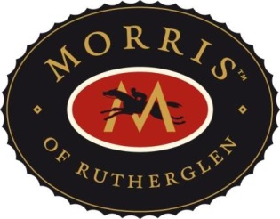
Jancis Robinson readily admits that neither her palate nor her brain were at their freshest when the late John Charles Brown of the famous Brown Brothers clan at Milawa, dropped her off on a hot summer’s day in 1981 at Morris of Rutherglen.
Australia’s most lauded fortified winemaker, Mick Morris, resplendent in filthy shorts and an even filthier shirt greeted a bemused Jancis with a laconic We’ll have yer full before yer leave – very Australian, very laconic, very Rutherglen!
Those Rutherglen vignerons are a tough, knockabout, distinctive lot – Walter Senior James, the doyenne of wine writers in the late 1950s and 1960s, may well have described them as Rutherglen Ragamuffins.
As may have the august André Simon, of the Wine & Food Society fame, who visited Australia 17 years earlier in 1964 and somewhat prosaically described Rutherglen as a producer of good sherries and a large amount of dessert wines, which must be better than most, since they are always given top prizes at Wine Shows.
Such Gallic – English insouciance! Morris Wines alone have won more gold, silver and bronze (but mostly gold) medals, awards and international acclamations than I have had hot dinners. Translate that into how many medals Rutherglen fortifieds have won collectively – probably enough in sheer volume and weight to sink Clive Palmers’ yet to be launched Titanic!
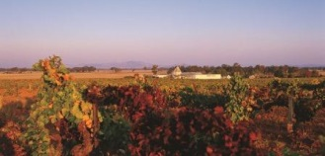

Back to the dust, flies and simmering heat of 1981 and a shell-shocked Jancis Robinson. On surveying the tin sheds comprising Morris at Mia Mia in the company of young Mick, she must have been struck dumb. Having come from an icy London winter to a sweltering North East Victorian summer she may well have contemplated saying to herself beam me up Scotty!
Hitherto the closest she had come to tasting anything that remotely resembled a renowned North East Victorian fortified was in northern Portugal’s Douro Valley, upstream from Oporto and home, of course, to the world famous ports.
No grandeur or aplomb in Rutherglen though, no famous Oporto Factory House, no airs, graces or beg you pardons, even for an up and coming Pommy wine writer of influence, just a motley collection of tin sheds, sweaty singlets and more flies than you could poke a stick at.
Replete with an Aussie swagger, a rustic pot still, dusty cellar floor and barrel after barrel the contents of which were ready to be blended or had lain dormant for decades having been blended eons ago – that’s Mia Mia.
Who said unearthing liquid gold was meant to be easy?
A rapturous Robinson.
Robinson’s description of what she sampled that day in 1981 is thus:
They’re made from ultra-ripe, nearly raisined grapes which are allowed to just start fermenting before a great whack of fiery young brandy is added to the sweet, grapey mixture and the blend is then added to older wine to be matured for years in a sort of solera system of ancient casks in furnace like sheds. I can’t think of any other winery anywhere in the world whose buildings qualify only as sheds.
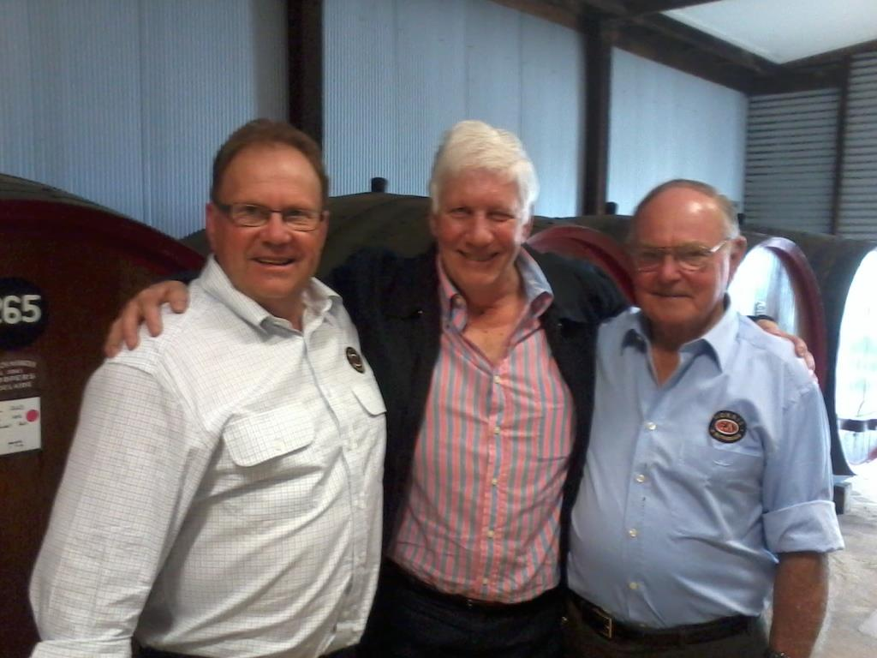
L-R: David Morris, Michael Hince and Mick Morris
Back in 1981 many an Aussie winery still resembled a collection of tin sheds, including some in the North East. Not everybody could afford a Mount Ophir homestead or an All Saints’ mock castle.
I wonder if Jancis ever made it to Best’s at Great Western and saw its eponymous tin shed.
Some bloody good wines come out of Aussie tin sheds, just ask Viv Thomson or Maurice O’Shea.
Laid out before Jancis that day were the crème de la crème of Rutherglen Liqueur Muscats and Liqueur Tokays (nowadays called Topaque) not just from Morris but from all its competitors.
And they say the life of a professional taster and wine scribe is easy – imagine sniffing sipping, (you don’t need to swirl) your way through flights of fortifieds in the heat with only a flimsy corrugated iron roof to keep the bottles in the shade, if not exactly cool.
The canny, exuberant Mick has assembled thirty samples of wine whose average alcohol content nudged 18%, however after much pleading by Jancis, he shrunk the selection to a mere twenty three!
After all it was not every day that someone like Jancis dropped in.
And to think, all most of us have to do is jump in our air-conditioned car and scoot up or down the Hume Highway to savour these sublime, unique fortified wines and luxuriate in liquid gold.
And Jancis’s verdict: They were wonderful wines. The Liqueur Muscats in particular are quite unlike anything else, truly a sort of warm Christmas cocktail of sherry, port, madeira and Muscat de Beaumes de Venise, and I have remained a fan of this style ever since.
Me and umpteen others too!
She concluded - Having to write intelligible notes on and assessments of a score of these things (wines) in the baking Australian bush, after a long morning’s tasting already, was quite a different experience – another English understatement!
Talk about extreme wines sampled in extreme conditions – I wonder if Mike Veseth of the Wine Economist mentions Rutherglen in his new book Extreme Wine?
Once you have tasted the likes of a Morris Rare Muscat, its essence is indelibly etched on your palate, it warms the cockles of your heart and sooths the troubled spirit – after all, so it should, it is liquid gold.
Fortunately I visited Rutherglen well before Jancis, the first time being around 1965 as a callow youth and have returned there numerous times. As many of my generation did, I armed myself with Doctor Sam Benwell’s Journey to Wine in Victoria guide - and in the company of some mates toured Rutherglen’s cellar doors and filled our car boot chock full with Durif, some sparkling reds, some Morris Muscats, Chambers Rosewoods, some Campbells, and some All Saints, to name but a few.
And from all accounts so did a young Will de Castella (the legendary Francois de Castella’s grandson). Says Will - People from all over can tell stories of their trip to Rutherglen, on the Red Rattler, of couples on push bikes traveling from winery to winery loading their panniers as they go, of groups of wine-loving friends on bus tours.
As did Will’s Great Grandfather Hubert (of St Hubert’s fame) who went from vineyard to vineyard in a horse drawn buggy with wine loving companions. No radar speed guns then!
That was well before .05 alcohol drink/drive limits came into force in Victoria.
True, there was the Yarra Valley then, but nowhere near as much of it as exists now and the Mornington Peninsula did not exist as a wine region back in the mid-sixties. Nearby Rutherglen was Milawa, then further south there was Tahbilk at Nagambie. Toward the West there was Seppelt and Best’s in Great Western en route to the Pyrenees and Grampians –and, of course Geelong - and nearer to Melbourne Sunbury. For the most part, that was it. Apologies to Mildura and the Riverland.
I cut my wine drinking and cellar door visitation teeth in the likes of Rutherglen and even at that young, unsophisticated, know-it-all age - I (and my friends) intuitively knew we had unearthed something special when we first dipped into the deep liquid brown and gold recesses of a Morris Liqueur Muscat.
Trying to describe the hedonistic, lingering, gob-smacking palate sensation of a rare Rutherglen fortified is like trying to describe a beautiful painting or Darwin sunset over water to a blind person – it’s a subliminal experience – and once had it stays with you seemingly forever.
Of course it helps to jog the memory occasionally by sipping a Morris Muscat when the urge grabs you – and what better time than now as I relive my recent visit to tin shed city – Morris at Mia Mia.
Fast forward to 2013
Fast forward to 2013 and wine critic Tyson Stelzer’s¹ take on the Morris Old Premium Rare Liqueur Muscat:
Last time I visited the Rutherglen wine show, old Mr Morris got up to receive trophies so many times that he moved his seat to the front of the auditorium, amid hoots of laughter!
(I like the old Mr Morris – so, I suspect, would Mick).
This wine accounted for most of the accolades, and deservedly so. 'Rare' means more than 20 years average age - but the real genius of Morris is its impeccable poise and seamless balance. This should be among the most expensive rare muscats, but it's the cheapest.
A treasure of the wine world. - Vintage: NV Score: 98 points.
Read on and I will tell you about a 100 point wine I tasted recently!
Stelzer continues: Morris is my house rare, because I adore it and because it is $57 at Dan Murphy s, making two 500mL bottles the same price as a single 375mL of most other rares. It’s a travesty that they can make a wine of more than twenty years average age and sell it at this price.
But the most bewildering thing is that most wine lovers don’t even know about it.
Stelzer is spot on - most wine lovers don t even know about this magnificent wine or about Morris and Rutherglen itself – let alone what vinous treasures lay waiting to be unearthed.
Morris is a metaphor for Rutherglen and while the price of gold (or in this case liquid gold) may fluctuate the value remains constant.
Do yourself a favour and discover Rutherglen’s unique fortified Muscats and Tokays - once you have you will instinctively want to explore Rutherglen itself, many times over.
It’s one thing for grumpy, oldish baby boomers like me to rabbit on about the good old days and historic wine regions like Rutherglen - it’s another thing altogether to say to Gen Y and the Millennials to ‘do yourself a favour and discover Rutherglen’s unique fortified Muscats and Tokays– and once you have you will instinctively want to explore Rutherglen itself, many times over’.
Wine is as much about people, places and stories as it is the wine itself. In this day of social media, wine apps and wine blogs it’s never been easier to dig for gold.
As Sam Benwell said in his Journey to Wine in Victoria - the great wine families of Rutherglen are those who can claim their establishment during the years of gold, or before.
If you can pick up a copy of Sam’s book at a good secondhand bookshop I suggest you do, it will give you a sense of the rich history of Rutherglen and Victorian wine generally.
Yes, there are other fortified and sweet botrytis wines from other places at home and abroad – many of which are brilliant, however there is only one liqueur Muscat worldwide and that is unique to Rutherglen.
Sam Benwell encapsulates Muscat perfectly: Morris’s Mia Mia is to be found the complete performance with Muscat wine. The best Muscats in the world are found in Australia, notably in Victoria, particularly in the far North-East, supremely at Morris’s.
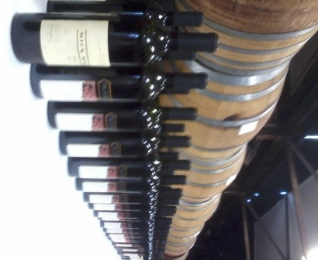
It may be a Morris, or a Chambers Rosewood, an All Saints, a Bailey’s of Bundarra, or whatever, that’s a matter for your taste and your palate to decide. One thing’s for sure, you will have fun deciding which wine and wine style from which maker you prefer.
For me the enduring benchmarks or bookends are Morris and Chambers Rosewood.
And if and when you make it to Rutherglen, I suggest you dine at the Terrace Restaurant at All Saints at Wahgunyah. (Another story for another time.)
Fast forward again to 21st October 2013 and David Morris’s 20th Anniversary Lunch and Tasting at Mia Mia – David and his dad Mick were a tad more sartorially attired than when Jancis Robinson visited 32 years ago, but outwardly the collection of tin sheds remained, likewise the old pot still, the cellar floor was still dusty and the welcome on arrival was typically exuberant and very Rutherglen!
From little grapes big wines grow – A New Age Durif
Prior to lunch, a vertical tasting of Morris Durif from 1990 vintage to the 2013 vintage revealed a consistency in style and structure, despite some normal vintage variation.
As the tasting progressed it unraveled to show that a bold, assertive wine, with bite and tannin grip which traditionally benefited from a good few years in the cellar, could be made into a more approachable, fresher, drink younger style, without sacrificing any of its attractive varietal characteristics.
This was progressively evident in the 2007 through to the current 2013 vintage flight.
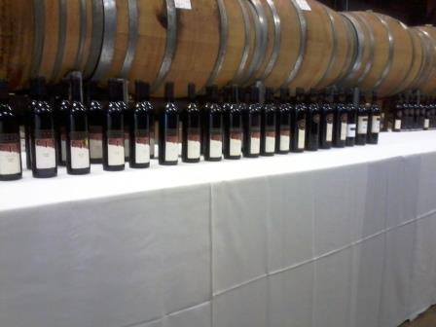
Other than above, I didn’t pick up any discernable difference between the pre 1993 and post 1993 Durifs, the ones Mick made and those David did, though others may have.
Durif was first introduced to Rutherglen in 1908 by Francois de Castella.
Lunch amid the barrels within the old cellar, was a treat, imbued with a sense of timelessness that comes when the company, the conversation, the conviviality, the cuisine - and the wine - meld to create an unforgettable occasion.
Executive Chef Veronica Zahra’s fare was exquisite - the highlight being a traditional Oxtail soup paired with a Morris Aged Amber Show Apera (Sherry) and a double cooked pork belly with parsnip puree and Apera glaze paired with a Morris Rich Golden Show Apera.
Sadly, both these styles of local Apera remain grossly under-appreciated and should be readily available at the host of Tapas bars popping up in Melbourne (and elsewhere) as an alternative or introduction to their Spanish forebears. Don’t get me (or Kim West) started on this!
Perhaps it’s a legacy of the bad old days when sickly sweet bulk sherry and plonk were synonymous. I suggest you buy a few bottles of both the Aged Amber Show Apera and the Rich Golden Show Apera and try serving them at the start of a meal by replicating the entrée above.
We lingered over lunch, so much so that the fortified tasting, which really demanded our full attention and concentration to match the style of the wines, seemed a mite too compressed for my post prandial palate.
By then we had tasted thirty one wines.
Number thirty two opened up the fortified flight. A Morris 5 Generations Aged Port and ten wines later when the Morris Old Premium Liqueur Rare Muscat finished the bracket, I had ascended to vinous heaven or was at least knocking on heaven’s door.
I now know how Jancis must have felt back in 1981, though it was nowhere near as hot as it was on her visit back then.
Heaven’s door opened!
For, on leaving Morris’s we were served a pre-Phylloxera fortified (which by my rough calculation had to be 114 years old – Phylloxera hit Rutherglen in 1899). Now I was truly in vinous heaven!
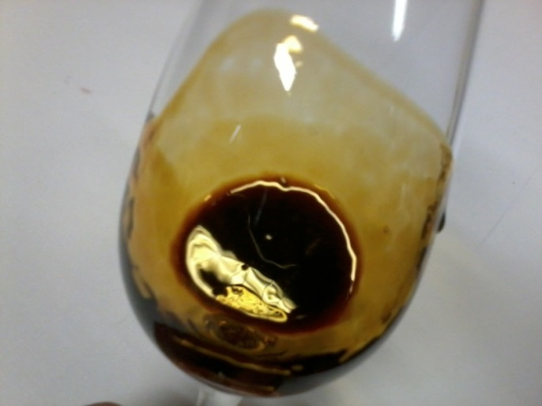
The 100 point liquid gold was so thick and treacle-like – as though it struggled to get out of the pipette, as did some of us onto the bus afterwards.
What a day! I left with some questions still unanswered. That’s wine, it invariably throws up more questions than it answer, especially in regard to where each Muscat best fits into the ever-changing Morris hierarchy. This is a question I will ask David when I talk to him early next year on Heard it Through the Grapevine.
As for Apera and its nuances, that gives rise to even more vexing and complex questions for both Morris and Rutherglen. So it is best left to another time and a future blog.
Rarely do you get to dine in the company of two consummate winemakers who between them have accumulated so many vintages crafting consistently good, brilliantly blended liquid gold.

Make Muscat a Must
All Morris at Mia Mia needs now is an informal bistro and a concerted campaign to get the missing generations into Muscat – I’m launching my Make Muscat a Must initiative tomorrow by serving some Morris to my Millennials at home.
Time to luxuriate in some more liquid gold! – Cheers, Michael Hince

